*Exercise 1-1: Run the Email list application*

**Step1**: Write a code of how the html page should like in a text editor and save it as email_list.css

**Step2**: Write a JavaScript linking the input fields of the index.html page using conditional statements. Save this file as email_list.js

**Step3:** Write a html code to display the contents of webpage where the user enters the username and first name and clicks a submit button. Save this file as index.html

**Step4:** Write a code to display the resulting webpage (provided that all the input fields are correct) which displays the message “thanks for joining” after the submit button is pressed on index.html. Save this file as join.html.

**Step5:** Place all the above files in the same folder and open index.html and see if the webpage looks as intended.

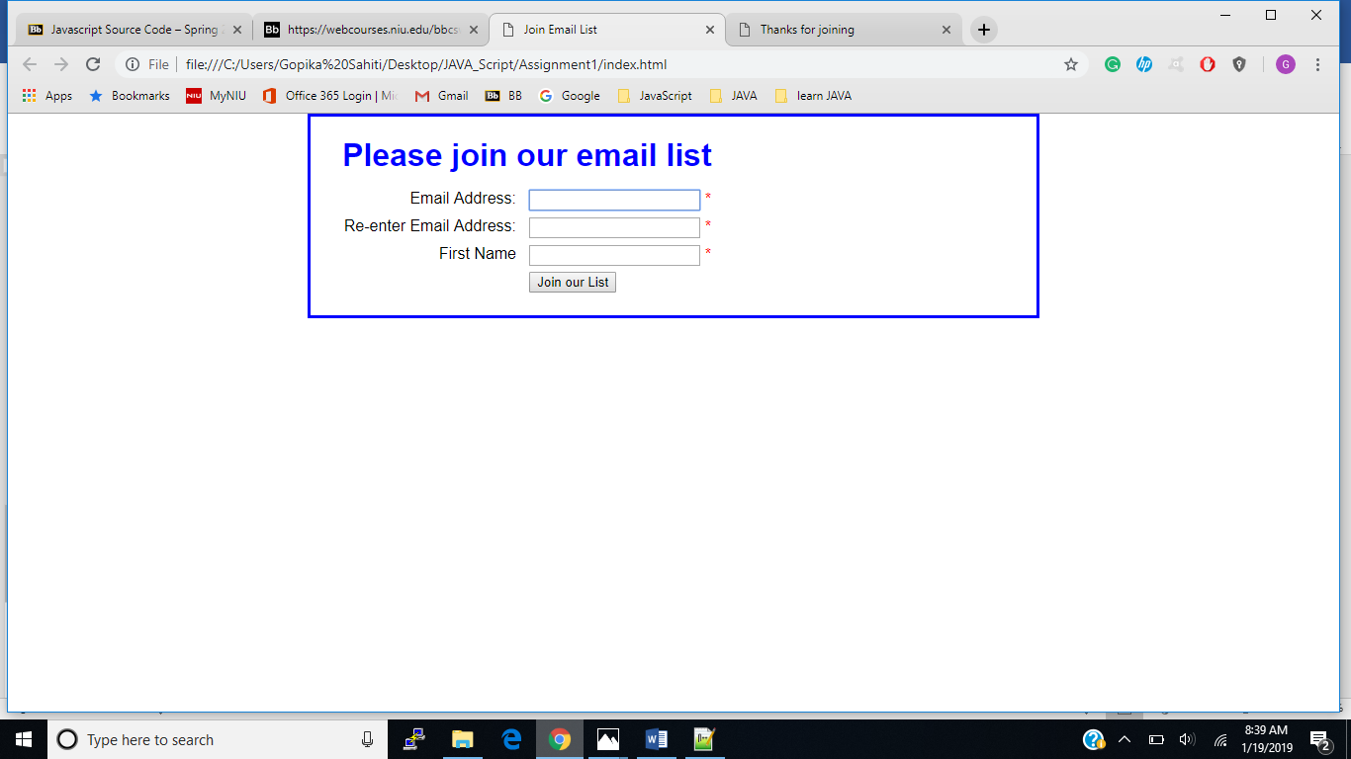

**Step6:** Click join our list button to test what happens when you don’t enter any data. It indicates that the required fields are to be filled to join the email list. We have written a code for this functionality in email_list.js

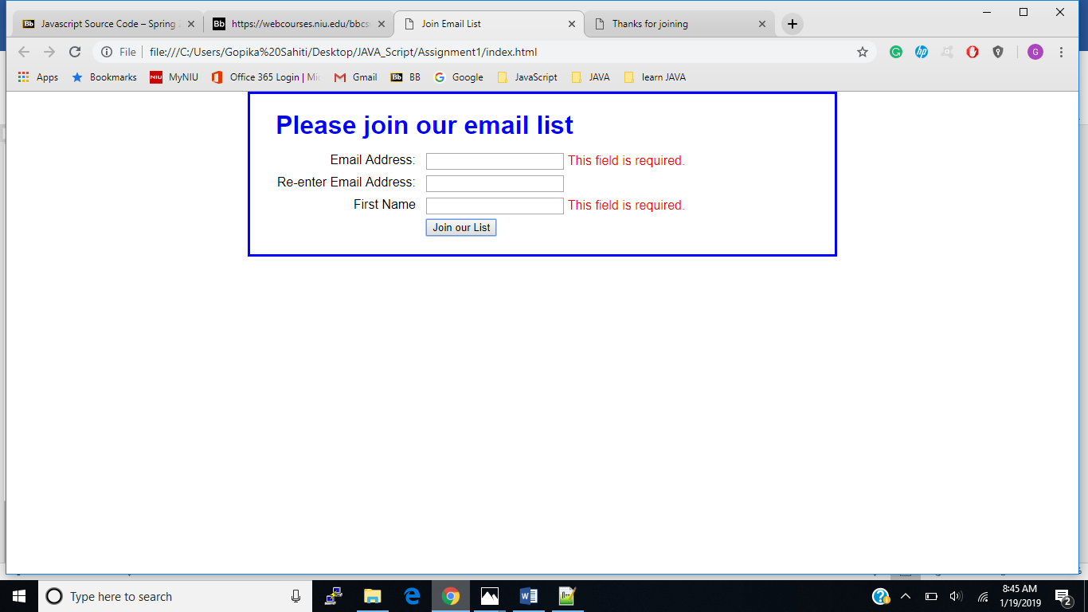

**Step7:** Enter email address in the first text box and invalid data in second text box and click join out list button to see what error message appears. It indicates and error saying that the second entry must be equal to first.

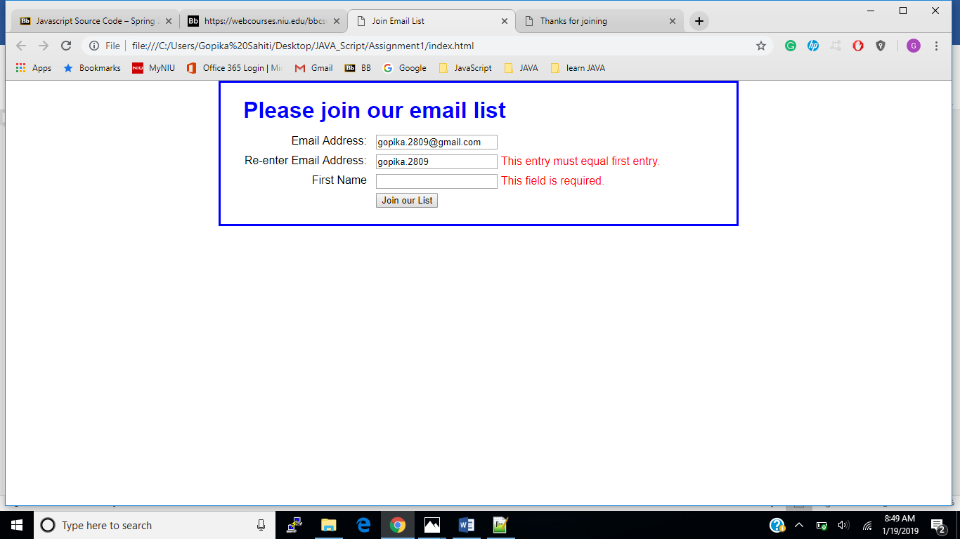

**Step8:** Enter valid data in all the three boxed and then click the join our list button to see the resulting webpage.

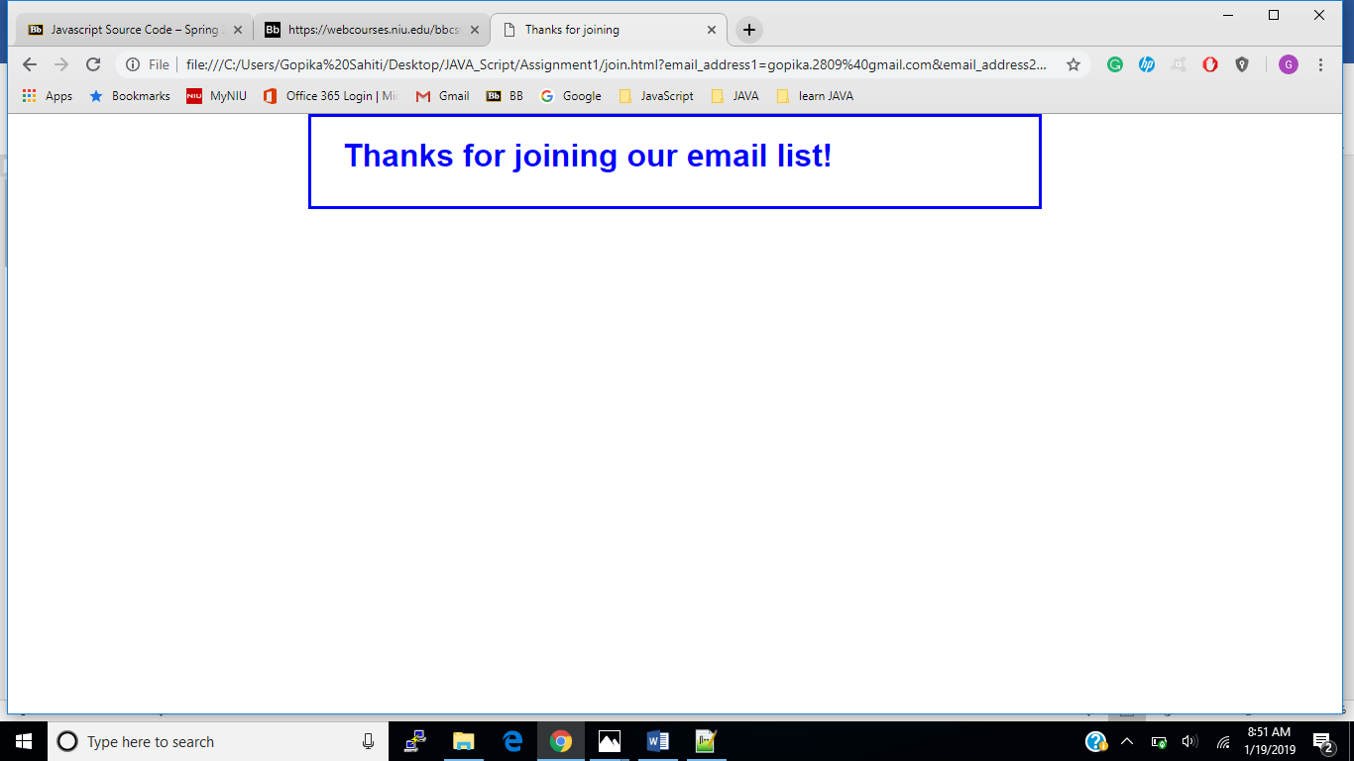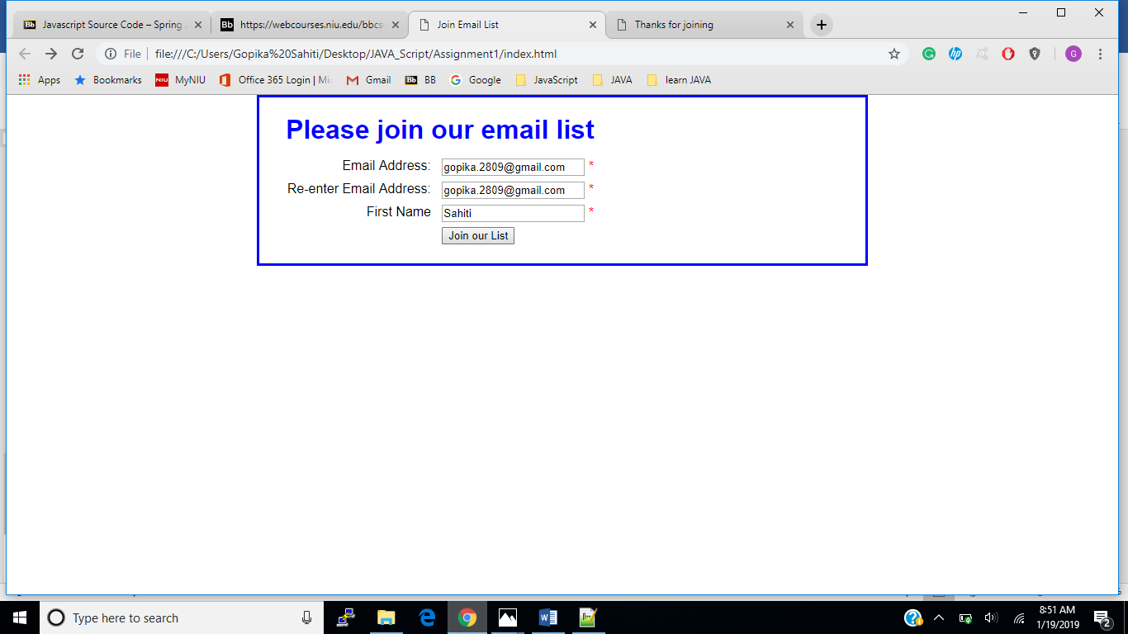

**Step9:** To rereun the application click on the back button and reload the page which resets the entries.

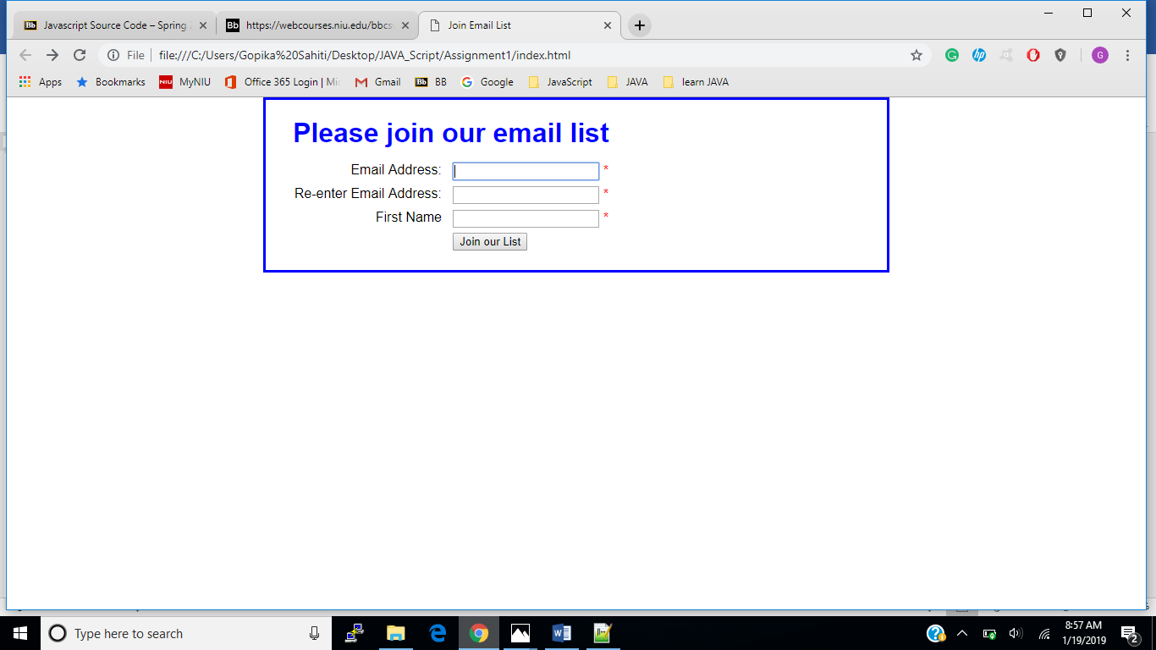

**Step10:** Enter email address in the first text box, leave the others empty and click the join out list button. Now open chromes developer tools and check if the console tab has any error messages.

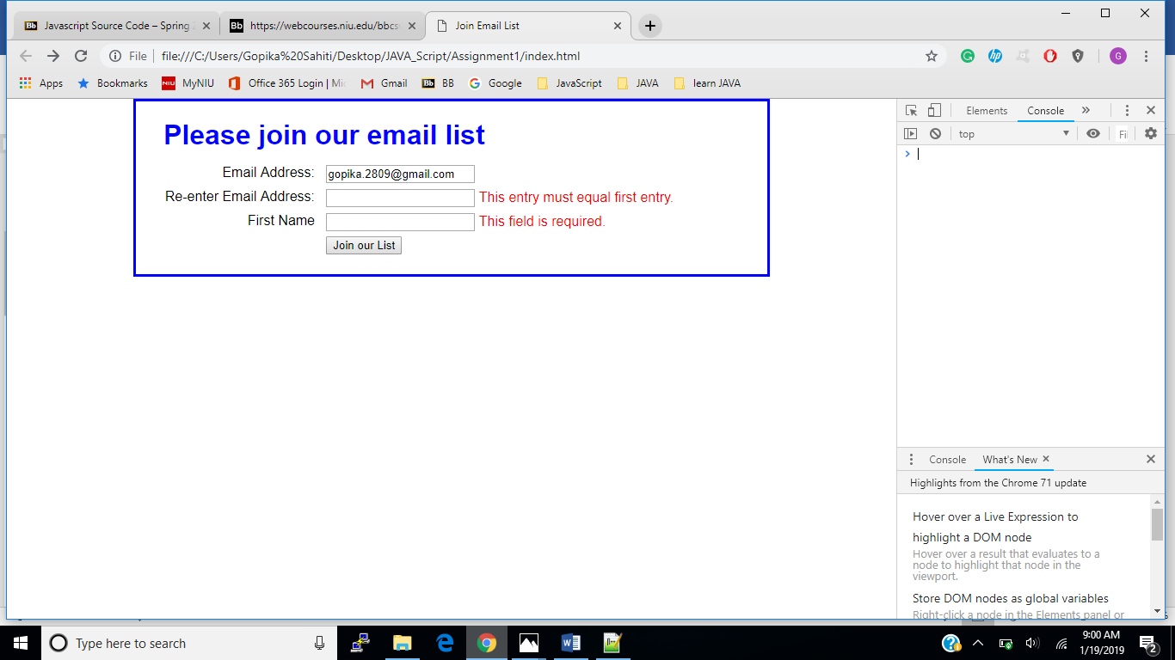**Step11:** Open the sources tab and click on email_list.js and index.html to see the codes for respective files. 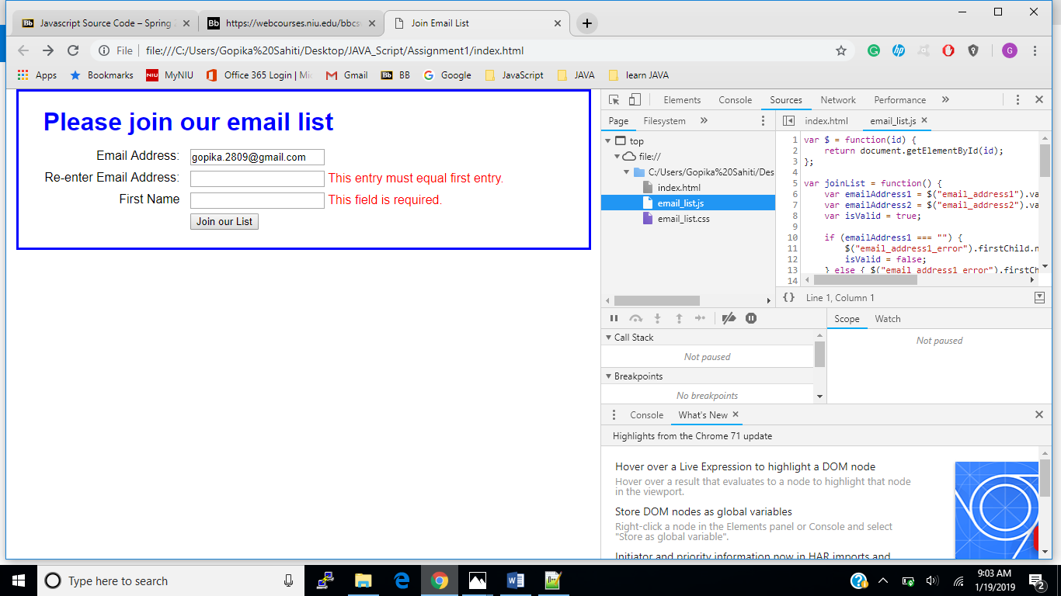

**Step12:** Click on the elements tab and we can see if there are any error messages in the span elements. The element tab represents the DOM of the page.

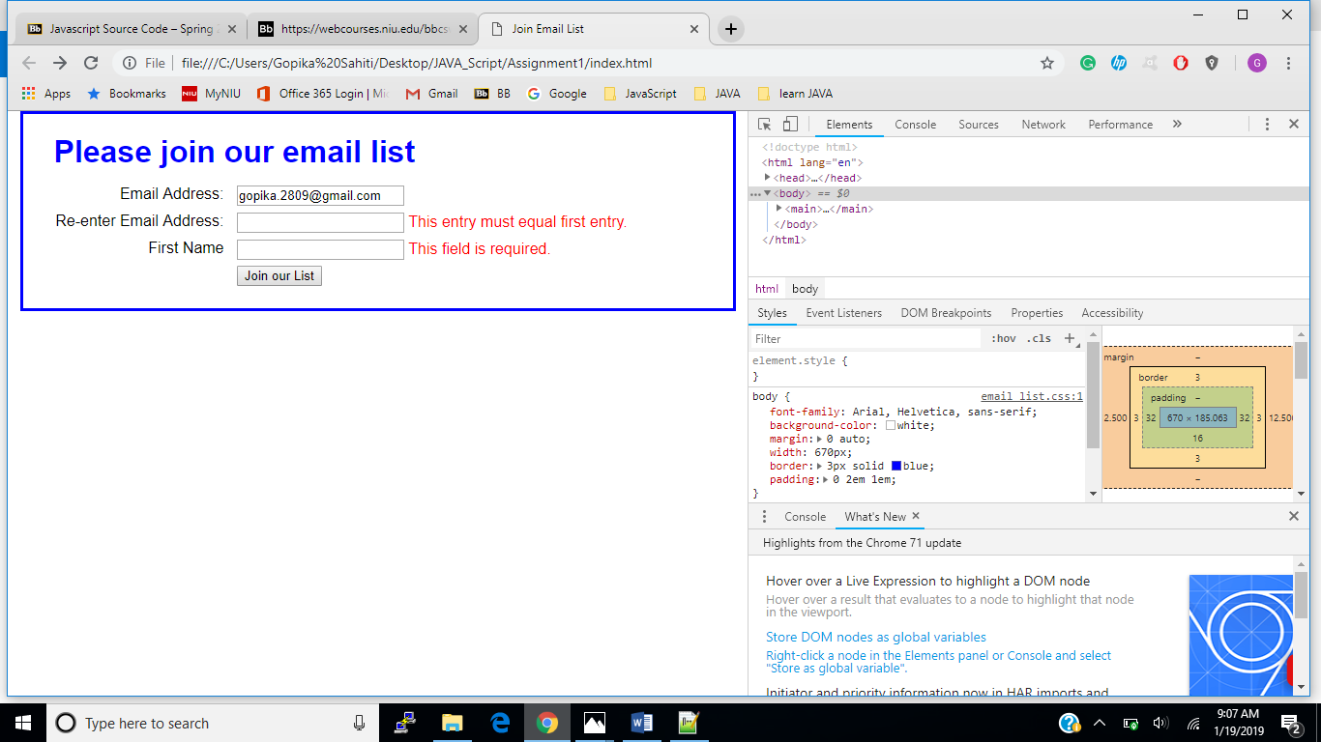

*Exercise 1-2 Run FAQ application*

**Step1**: Write a code of how the html page should like in a text editor and save it as main.css

**Step2**: Write a JavaScript which denotes the functinality of the page. Save this file as faqs.js

**Step3:** Write a html code to display the contents of webpage. Save this file as index.html

**Step4:** Click the heading to display the text and again click the heading to hide the text.

